RESUME
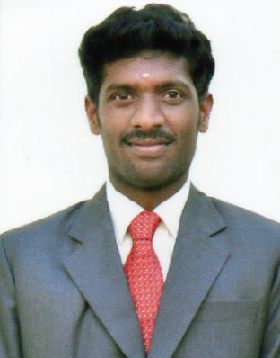
D.Vijay
email:vijay.devan05@gmail.com
Mobile number: 9943971068

Objectives:
To get aligned with a reputed firm or company to get a deeper insight into the present education and utilize my skills and abilities in the industry that offers professional growth while being innovative and flexible.
Educational qualification:
Degree | University / School | Year of Completion | Percentge of Marks
MBA[B&I] | Alagappa university | 2016 | 58%
BCOM[CA] | Ananda collage devakottai | 2013 | 66%
12th | De.britto.her.sec.school devakottai | 2010 | 79.91%
S.S.L.C | De.britto. her.sec.school devakottai | 2008 | 57.6%

Project work:
Project Title: A STUDY ON CUSTOMER SATISFACTION OF PENSION LOAN
Bank name: Indian Bank koodal nager branch Madurai
Duration. : 45 days

Personal Information:
Date of Birth : 05.7.1993
Nationality : Indian
Father's name : P.deventhiran
Permanent Address : 118,vallal Azhagappanagar,
Nagavayal road,
Devakottai rastha,
Karaikudi -630005.
Marital status : Single.
Languages known : Tamil & English (read, write, speak)
Soft skill : HDCA,Tally.
Experience : Business Development Executive 2 months
Company : Axis bank
DECLARATION
I hereby declare that the information and facts stated here in above are true, correct and complete to the best of my knowledge.
Place :Chennai D.VIJAY
Date :

